Q1

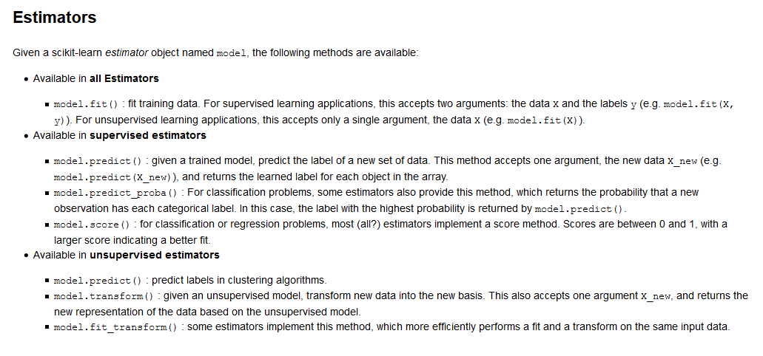

In scikit-learn, an estimator for classification is a Python object that implements the methods fit(X, y) and predict(T).

Now you can predict new values, in particular, we can ask to the classifier what is the digit of our last image in the digits dataset, which we have not used to train the classifier:

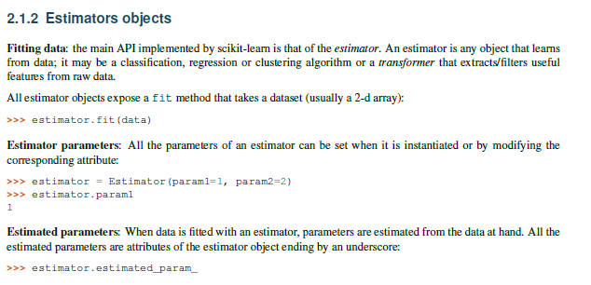

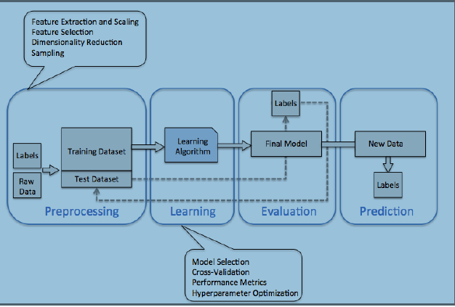

k

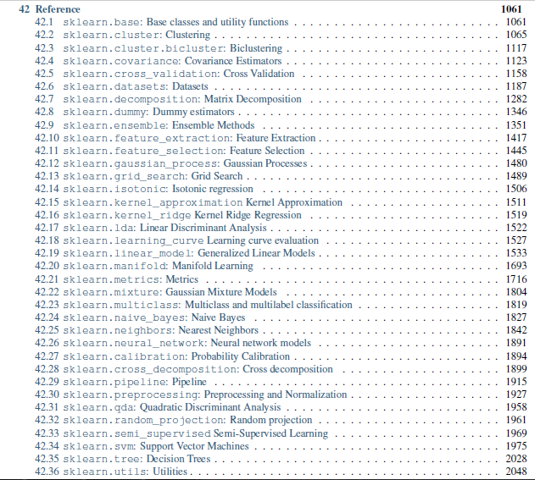

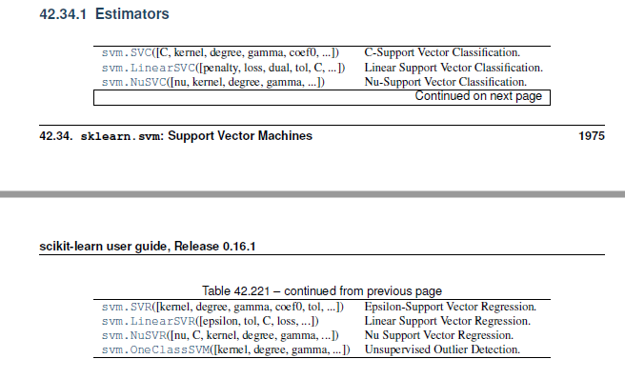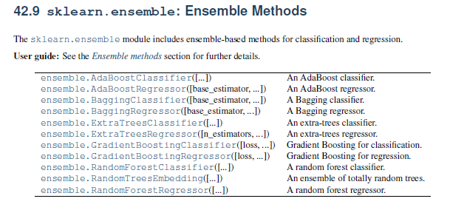

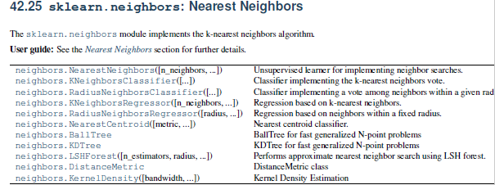

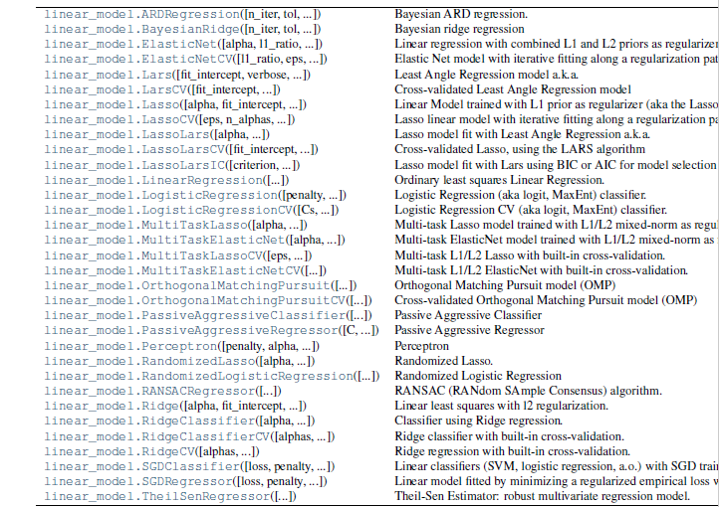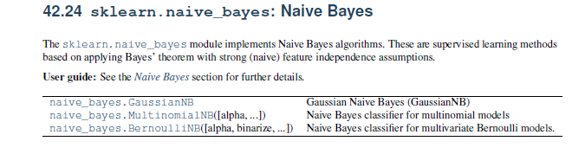

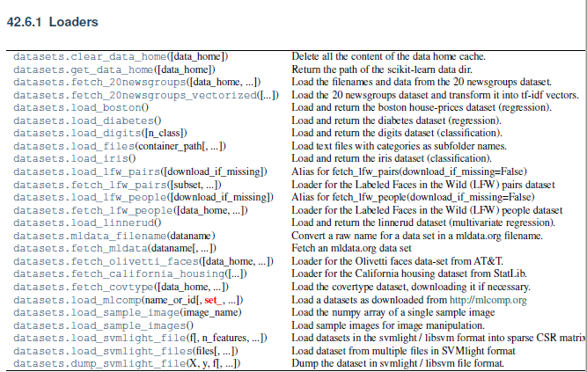

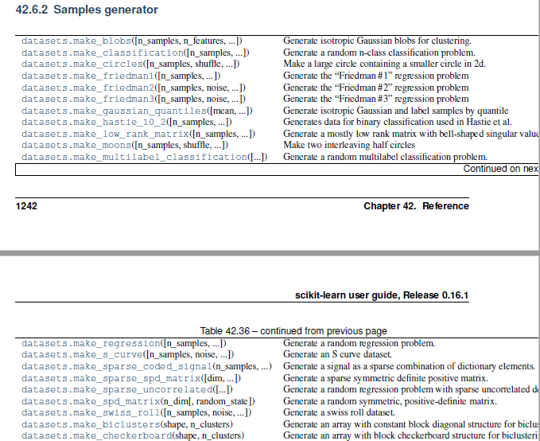

-----------------------------------------------------------------------------------------------------------------

ML Techniques

* Linear Regression
* Naïve Bayes
* SVM (Support Vector Machines)
* Random Forrest
* PCA (Principal Component Analysis)
* Manifold Learning
* K-mean clustering
* Decision Trees
* ANN (Artificial Neural Network)
* Gaussian Mixture Model
* Kernel Density Estimation

Broad type of data analysis in Scikit-learn

1. Classification (Supervised)

* Naïve Bayes
* K Nearest Neighbors
* SVM
* Random Forest classifier
* MLP
* Logistic Regression

1. Regression (Supervised)

* Linear Regression
* Ridge Regression
* Lasso
* SVR
* K Nearest Neighbor regression
* Decision Trees & Random Forest regressor

1. Clustering (Unsupervised)

* PCA
* K-means
* GMM
* DBSCAN

1. Dimensionality Reduction(Unsupervised)

* PCA
* Manifold learning

**API**

**from sklearn import** svm

from sklearn.linear_model import LinearRegression

from sklearn.cross_validation import train_test_split

Xtrain, Xtest, ytrain, ytest = train_test_split(X_iris, y_iris, random_state=1)

#above module is deprecated. Use model_selection instead.

from sklearn.naive_bayes import GaussianNB

from sklearn.decomposition import PCA

from sklearn.mixture import GaussianMixture

from sklearn.neighbors import KNeighborsClassifier

from sklearn.cluster import KMeans

kmeans = KMeans(n_clusters=2)

from sklearn.metrics import accuracy_score

from sklearn.cross_validation import cross_val_score

cross_val_score(model, X, y, cv=5)

-------------------------------------------------------------------------------------

|  |  |  |  |  |
| --- | --- | --- | --- | --- |
| **Task Type** | **API** | **Methods & attributes** | **Key parameters** | **Estimated parameter** |
| Classification | sklearn.naive_bayes.GaussianNB | fit(X,y), predict(X),  score(X,y) etc | No param. | model.class_count_, model.class_prior_, model.classes_ |
| Classification | sklearn.neighbors.KNeighborsClassifier | fit(X,y), predict(X),  score(X,y), | n_neighbors=5 | knn.classes_, knn.effective_metric_, knn.outputs_2d_ |
| Classification | sklearn.svm.SVC | fit(X,y), predict(X),  score(X,y),  coef_ | C=1.0, kernel=’rbf’, degree=3, gamma=’auto’ | model.support_vectors_ , model.support_, model.coef_, model.n_support_ |
| Classification | sklearn.tree.DicisionTreeClassifier | fit(X,y), predict(X),  score(X,y),  max_depth(int) | max_depth=None,  min_samples_split=2, min_samples_leaf=1,  min_weight_fraction_leaf=0.0,  max_features=None, |  |
| Classification | sklearn.ensemble.RandomForestClassifier | fit(X,y), predict(X),  score(X,y), | n_estimators=10 () |  |
| Regression | sklearn.linear_model.LinearRegression |  | fit_intercept=True, normalize=False,  copy_X=True, n_jobs=1) | model.coef_, model.intercept_, model.rank_ |
| Regression | sklearn.linear_model. |  |  |  |
| Regression | sklearn.linear_model.Ridge |  | alpha=1.0, fit_intercept=True | model.coef_, model.intercept_, |
| Regression | sklearn.linear_model.Lasso |  | alpha=1.0, fit_intercept=True | model.coef_, model.intercept_, |
| Regression | sklearn.svm.SVR | kernel=’rbf’, degree=3, gamma=’auto’, coef0=0.0, tol=0.001, C=1.0, epsilon=  0.1 | C=1.0, kernel=’rbf’, degree=3, gamma=’auto’ |  |
| Dimensionality Reduction | sklearn.decomposition.PCA | fit(),transform(),  fit_transform(), inverse_transform(),score() | n_components=None | model.components_, model.explained_variance_, model.explained_variance_ratio_, model.noise_variance_ |
| Clustering | sklearn.cluster.KMeans | fit(),predict(),transform(),predict_transform(),score(),  fit_transform(), | n_clusters=8, | kmeans.cluster_centers_, kmeans.labels_,kmeans.n_iter_ |
| Clustering | sklearn.mixture.GaussianMixture | fit(X,y), predict(X),  score(X,y) etc | n_components=1, covariance_type=’full’ | converged_, covariances_ |
| Clustering | sklearn.cluster.DBSCAN | fit(),fit_predict() but no predict() method | eps=0.5, min_samples=5 |  |
| Density Estimation | sklearn.neighbors.KernelDensity | fit(), score() but no predict() or transform() method | bandwidth=1.0, algorithm=’auto’, kernel=’gaussian’, |  |